ZULU TRAIL, MSINGA, KZN
REPORT ON THE VISIT OF STUDENTS FROM GERMANY, SWITZERLAND AND NETHERLANDS
22 TO 31 MARCH 2018
BY
SANDILE MASONDO

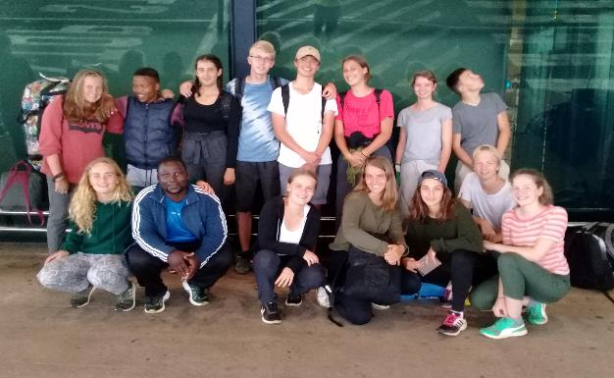
‘Of all the paths you take in life, make sure a few of them are dirt.’

ZULU TRAIL REPORT – 22 TO 31 MARCH 2018

The trail guides: SandileMasondo, SiphoMsiya and PhilisiweMasondo.
Trail participants: students from CT | Total | Teachers | Gender: | Male | Female
Number of students | 13 | 0 |  | 4 | 9
Number of guides | 3 |  |  | 2 | 1
Total | 16 |  |  | 6 | 10

AreasVisited:Msinga, MphandeniNtanyana, KwaKopi, KwaMbhono and Ngubevu.
Since the relaunching of the Zulu Trail in 2014, our trails have mainly linked Nkandla and Msinga but this year we started a new route linking Mudeni and Ngubevu via Impofana and the UThukela River.
The students arrived at King Shaka International Airport on Thursday, 22 March at 11h55. The group consisted of 13 students –9 girls and 4 boys. The girls were: Johan Von Alvdensleben 17, Tamara Steiver 17, LaurzKuppes 17, Lina Asmussen 17, Hanna Weiler 16, Aaron Axt 16, Luna Vanters 16, Luisa Romer 16, FelicitasNordmann 15.The boys were: Emely Schilling 16, FriederikeDenk 16, Courad Braun 16, and Jakob Nagel 15.
Day 1: On their arrival I gave the students a warm welcome. We used a 15-seater Toyota Quantum as our transport. We left the airport at 12h30 then drove on the N3 route via Pinetown (Kwelikabhanana). The main reason for taking the N3 route was to collect Sipho and Philisiwe who were in Pietermaritzburg because I left the previous day to collect the taxi from Vee Transport and so I had to sleep in Durban. Our journey took us 3 hours and 30 minutes. We travelled up in convoy for the trip from Pietermaritzburg to our drop-off at Mudeni.
There had been a lot of rain and the sand roads were muddy and slippery, making it difficult to manoeuvre the vehicles. In some places we had to stop and get out of the vehicles to push them. 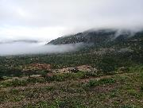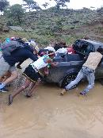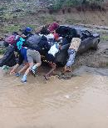
The weather was cloudy and overcast.We had to push our one vehicle that got stuck in a small stream

Day 1 & 2: We were very happy to reach the KwaJali family homestead, at Mphandeni, the first homestead where we going to be staying. We were welcomed with a big fire and warm water to bath. Afterwards we spent time to do a proper briefing where we explained the objectives and the goals of the trail. We gave the students the history of the Zulu Trail (ZT) starting back in 1985.
The plan for this group was to teach them a traditional song with a particular dance (imvunge) that was going to be shown at the end of the trail at Ngubevu. Since the weather was bad the rehearsing took place indoors inside the rondavel, Nkosiyomusa Jali is the leader of the local dancing group who played a major role in teaching the visitors a simple dancing routine, I have to say, it was very difficult to teach people who do not follow the rhythm of the song but at the end we were able to create a better choreography.

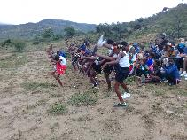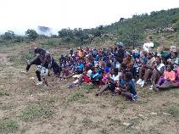
Teaching the visitors the Zulu dance
At night we had storytelling and gave the visitors a chance to ask questions about the Zulu culture, some of the question were about religious beliefs, ceremonies, death and afterlife, marriage and families and many more.
These are summaries of some of the answers that were given:
Religious Beliefs-The Zulu people have a strong belief in the potency of their ancestors. Their cosmology is characterized by God in various forms: uMvelinqangi (a male god responsible for all life), UNomkhubulwane (a female god who provides food security, particularly through good harvests, and for the control of weather, particularly thunder). Their cosmology also includes ancestors who can have a significant positive impact on the lives of their families, if they are appeased. The Zulu cosmology also includes the potency of the natural world, particularly herbs and animals when made into Umuthi(medicine) that can be used (or abused) to affect people positively (or negatively). This is done mainly in the realm of traditional medicine.
Death and Afterlife: Death is regarded as a time of tremendous loss. A death by illness is treated differently from a death by ‘a spill of blood’ Accidents and death by murder are regarded as deaths by ‘spill of blood’ and medicinal healing is expected to accompany the funerals in these cases in order to stop such misfortunes (UkuvalaUmkhokha). Generally, deaths are considered polluting, and various rituals and ceremonies must be observed to slowly remove the impurity. These rituals also serve to gradually send the deceased into the next world.
Day 3: The weather was good which allowed us to move to our second homestead. We walked 8km from Mphandeni to Kwakopi. This village is on top of the valley from where you can see the two big rivers, UThukela and Impofana in the east. You are blessed by four magnificently big rocks that are placed on top of the mountain (Ematshemane). There is a legend that only the very good Sangomas went there for their initiation processes and that these Sangomas were able to communicate with the mountain spirit. We slept at the KwaDlamini family homestead where we enjoyed intestines as our supper.
Day 4: The boys were up early. Their task was to herd the goats and take them to the mountain for grazing but, before doing that, they needed to separate babies from mothers because wild animals, jackal and wild cat, prefer baby goats as their favourite meal. To do this job properly you are required to catch babies before they follow their mother. This work was meant to be done in less than 30 minutes but it took 1hour 45 minutes the problem being that all the boys feared that the goats would eat them alive and they had an idea that goats are territorial animals and they will do anything to defend themselves. When I disagreed with their statement, we spent more than 45 minutes on the internet trying find cases where a human was eaten by a goat. To their surprise, we did not find anything relating to that. With the help of a young boy they were able to catch all of the baby goats in 20 minutes.
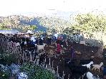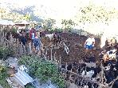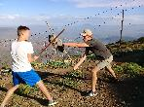
Separating the adult goatsand the young ones. The boys playing stick fighting

We left the Dlamini family homestead at 7h00 to walk 9km to KwaMbhono village. Along the way we separated into two groups because some students wanted to walk faster than the others. This decision created a problem in the end because the slow group followed the correct route and arrived at their destination at 12h30. The group that wanted to walk faster were the ones with the problem. Instead of listening to the guide, they were following the map and looking for places with no steep terrain. They got lost and arrived at 18h30 in the evening.
Day 5: We did a short 5km walk to Ngubevu. Later in the day, I took Jakob to Hilton hospital because he had a problem with breathing and he suspected that he had a heart problem - as diagnosed by doctors he had seen while he was still in Cape Town. He was admitted to the hospital, where they did tests but they did not find anything related to a heart problem. Instead they found that his muscles were strained from lifting heavy objects. He admitted that he was doing weight lifting in Cape Town. He was discharged the same day and we slept at HannesZollner’shome in Howick.
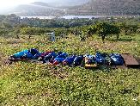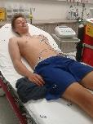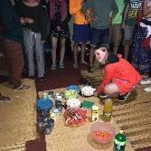
Sleeping outsidewith one student missing.Jakob in the hospital. Celebrating Luisa’s birthday
Day 6: The students played soccer against the local team. The visitors lost 5 goals to 0. Later in the day we had Zulu dancing. Luisa Romer was having a birthday and we bought a cake to celebrate the special day with her.
Day 7: We visited a family who was having a ceremony of bringing the spirit back home using a branch of umlahlankosi. In our Zulu culture we believe that our deceased loved ones are our ancestors and we highly respect that. When a person dies, he or she joins to the family members who have also died. We believe that our ancestors watch over those who are still alive and act as a mediator and is in the middle between us and God (Umvelinqangi)
Day 8: We left Ngubevu at 11h00 and drove to Sugar Field Lodge, where we arrived at 15h00.
Day 9: We spent the day at Thala where we drove round the park, stopping to watch animals.
Day 10: We held a feedback session with the students find out about their response to the Zulu Trail experience. On our way to the airport we stopped at Gateway mall to buy souvenirs, the flight left Durban 17h15 to Cape Town.
At the end of the Zulu Trail, during the feedback, this is what students had to say:
Highlights of the trail
- Spending time with the local Zulu people and learning about a new culture
- Conversations with the guides
- The cultural ceremony - this was the biggest highlight for everyone
- Visiting the game park at Tala
- Sleeping on grass mats (icansi) outside and watching the stars at night, and doing night watch
- Listening to the music. Traditional Zulu dance music
- Friendly guides
- A good driver
- The walk, especially when we get to the east seeing the landscape
- The warm welcoming at Nkomo’s house, and playing with people in the area
- The soccer and netball matches were big highlights
- Visiting the school was very nice - the singing at the school is professional
- To be given the possibility to decide what we are going to do and to be appreciated
- Making Ujeqe (Steam bread) was the best
- The guides,Sandile and Sipho, were very good in everything. Please never change guides
- The ritual of slaughtering the goat and the cow
- When we got lost on the mountain
- The people from the area who are very friendly and who represent what is called community
- Not having my phone
- The group activities were very good

Personal change
- I learnt that you have to take the best out of every situation and try to be happy
- I'm going to be open to new ideas and situations
- Learn to live with less things because it is possible
- Be more thankful for everything you have
- You don’t need a lot to live a good life
- Zulu Trail has taught me to respect other human beings and give them a chance to tell their story so I can learn from them

Lowlights and Suggestions
- No lowlights
- No suggestions - Everything was perfect!

